# Python on the Hockerill system

Python is a programming language designed to be easy to program with. There is very little punctuation. It is also a flexible and powerful language. In this file things to do are in **red** or gold and code to try out is in **green**. Questions to answer or sentences to complete are in **purple.**

## Part one: Where to find it

Python version 3.11 is installed on the system. To create, test and edit programs there is also the IDLE development environment. Search for ”IDLE” and **Run the Python IDLE**

Repl alternative:

Make/use an count at repl.it <https://repl.it/@enaard/Python-3>

Download/use python with IDLE on your device: [Download Python | Python.org](https://www.python.org/downloads/)

## Part two: Python Shell Practice

IDLE

## Enter the green commands below at the >> prompt

1. **output to Python shell**:

>>> **print("Hello, World!")**

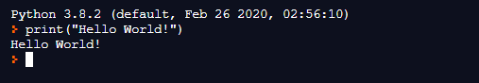

repl

**This is your first Python statement what does it do?**

**Use the print command to output other messages…**

2) **What if you get it wrong**? Try these

>>> **Print(“hello”) The error is…**

>>> **print(hello) The error is…**

Python is case sensitive so the p of print must be lower case and text needs to be inside quotes.

3) **simple maths** (the symbols to use are the same as Excel):

IDLE

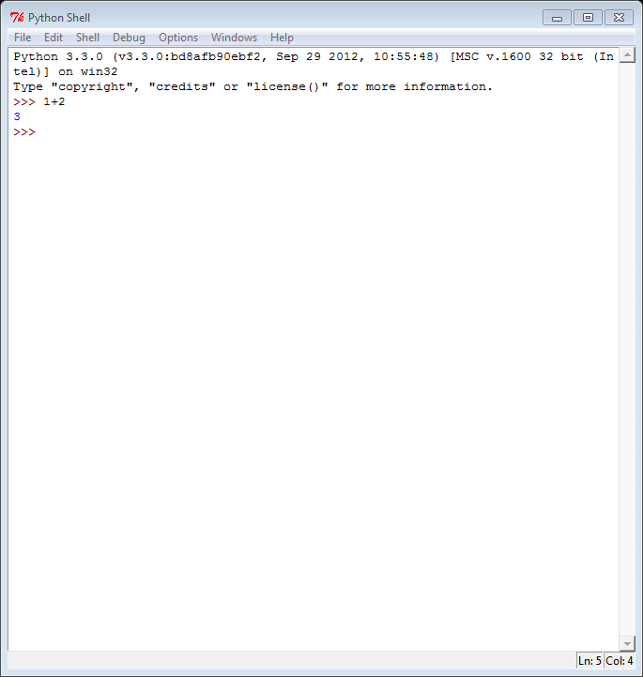>>> **1+2**

repl

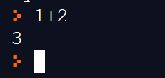

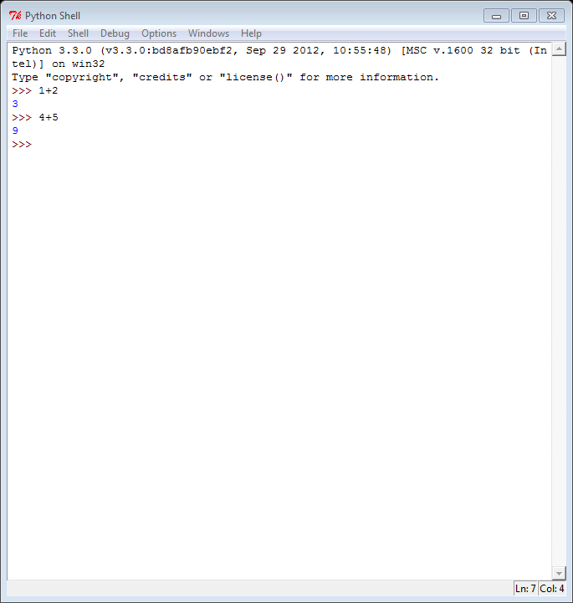

>>> **4+5**

>>> **6-2**

>>> **4*5**

>>> **3/2**

**Try entering some more maths expressions into the python shell** like **3**2**

What does the ** symbol mean?

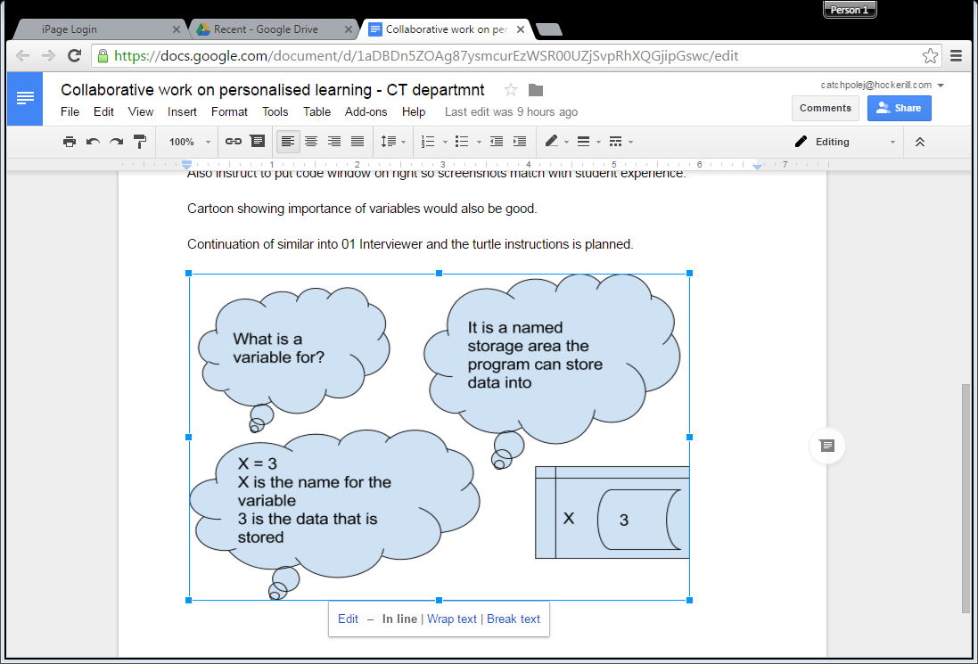5) **Variables**

a)…………………….. Use an integer variable to store a number and then output it

>>> **x=2+2**

>>> **print(x)**

b) ..………………… Change the value of the variable before you output it

>>> **x=1**

>>> **x=x+2**

>>> **print(x)**

**What is the value of x in the end in the example just above?**

The command x=1 is an assignment statement. x is the label or variable name that points to a place in memory where some data can be stored. The programmer (you) can choose what variable name is used.

………………………. Use your choice of variable name

>>> **your_choice = 7*7**

>>> **print(your_choice)**

5) getting some information from the user into a string variable then outputting a message using the string variable:

>>>**answer = input("How are you finding Python so far?: ")**

You will need to enter an answer to this question (i.e. easy, weird, difficult, boring, fun, OK so far)

>>>**print ("You are finding Python ", answer)**

**The instruction that gets your answer is**

**The answer that you type in is stored in the variable**

**The instruction that outputs your answer in a sentence is**

## Part three: IDLE Editor practice

If we want to do more complicated things it is very easy to make a mistake. If you are using the Python shell and you make a mistake you have to start over.

Using the IDLE or repl editor means we can edit the code and keep trying it until it works. You can create programs you can save into your documents.

Select File🡺New Window to open the IDLE editor.

Repl alternative: On the repl site the editor is this window and the code is stored in repl folders

### 

If you want the editor window when you launch Python in the future.

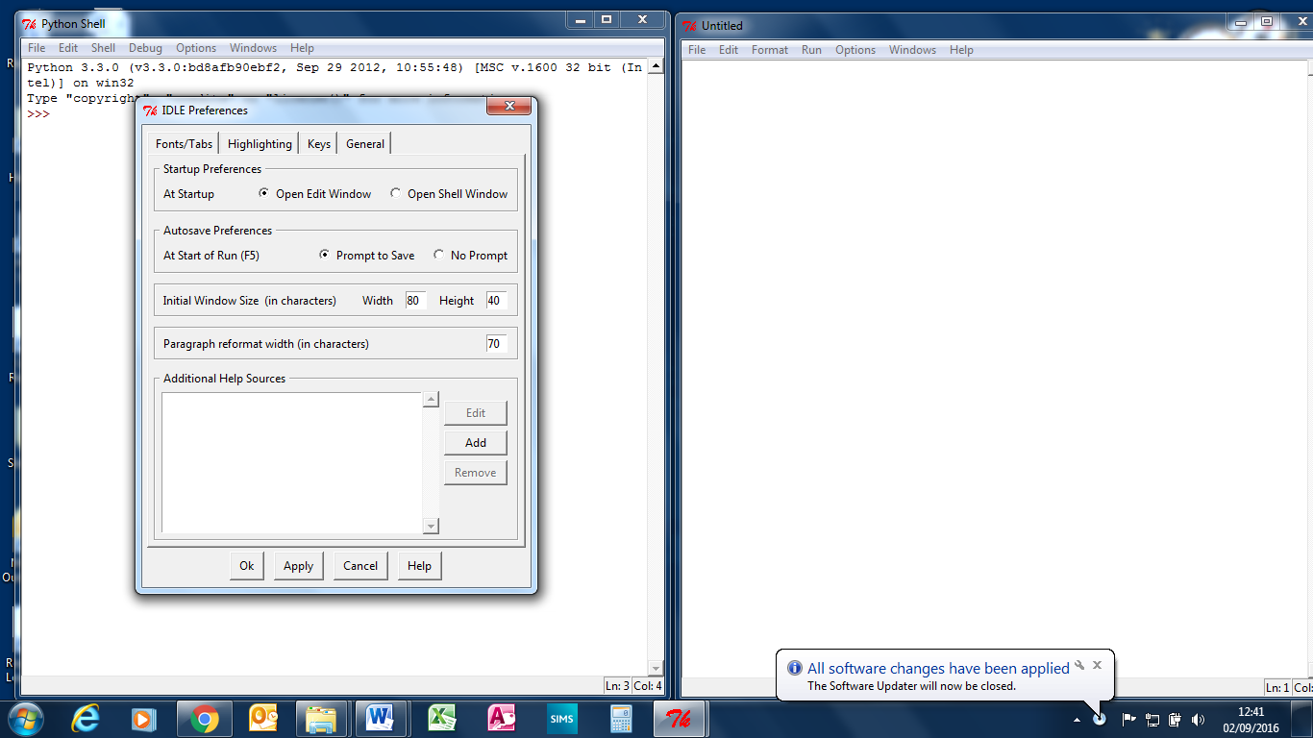In the options menu change the General tab to ‘open edit window’.

You now have two windows showing on your screen. Maybe arrange them so you can see both at the same time.

Create the hello world program in the editor window as below

**print(“Hello, World!”)**

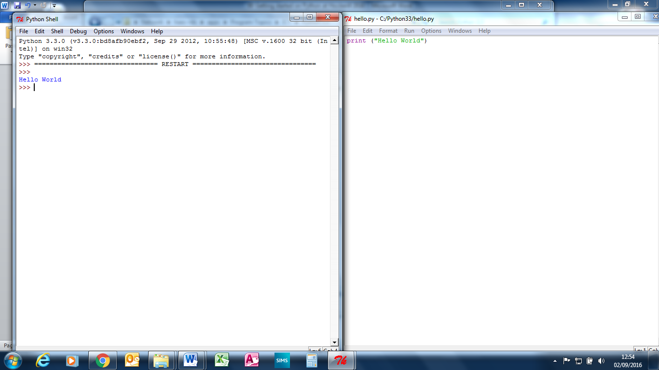

This is the editor. This is where you create and save programs.

select Run, Run Module (or press **F5**) and choose a sensible place (make a OneDrive folder) and filename for your program file.

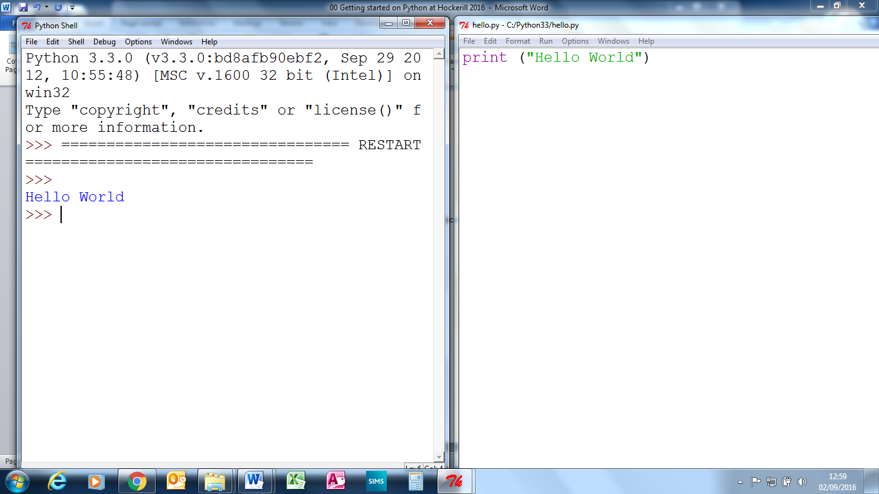

**This is the output from your program.**

**Where does the output go to?**

**Add another print statement to your program. What runs when run the code now**?

### More practice

Put the 2 line of code for the how are you finding python question and answer into your program and get it to work. Maybe try changing the prompt text and the variable name to make the program different or add more lines using input and print.

1. **A slightly clever program**

**Start a new program with these four lines.**

**print("I am a Python program, I would like to know who has made me")**

**maker=input("Please enter your name: ")**

**print("Thank you ",maker)**

**print("Your name has",len(maker), "letters in it," ,maker)**

**Test this first part of the program (press F5)**

**What does the statement len(maker) do?**

**Add these lines to the end of your previous program:**

**age = input("How old are you? ")**

**if(int(age)>len(maker)):**

**print("Your age is greater than the number of letters in your name")**

**if(int(age)<len(maker)):**

**print("Your age is less than the number of letters in your name")**

**if(int(age)==len(maker)):**

**print("Your age is equal to the number of letters in your name")**

**This block of code contains**

**if(int(age)>len(maker)):**

**print("Your age is greater than the number of letters in your name")**

**elif(int(age)<len(maker)):**

**print("Your age is less than the number of letters in your name")**

**else:**

**print("Your age is equal to the number of letters in your name")**

**This block of code does the same thing but contains**

Do you understand everything so far? **If not ask.**

## Part four: Next steps

After completing the getting started there are a few possible options.

If you like the idea of doing more programming and did not install python yet install Python on your own computer. It is free!.: <http://www.python.org/getit/>

Some students like using pycharm for programming python; install the community version from: <https://www.jetbrains.com/pycharm/download/> - maybe watch an installing pycharm youtube video for your operating system first.

**More options:**

1. Python Art section of <https://www.hockerillct.com/16/CT/year8/>
2. Try the 01 Interviewer exercise or Python for Kids then the other exercises in this folder.

<https://haec.sharepoint.com/sites/CTstudentresources/Shared%20Documents/Forms/AllItems.aspx?originalPath=aHR0cHM6Ly9oYWVjLnNoYXJlcG9pbnQuY29tLzpmOi9zL0NUc3R1ZGVudHJlc291cmNlcy9Fak5mMm51SGwyaEN0RVNKSlZDc3J5NEJRcDBvbXQzdWlkYnhqVWh4eUhTRjRRP3J0aW1lPTVPN0dlaXlEMlVn&viewid=94b7cf4d%2De26f%2D459d%2D9f1f%2D83d4b2eca3c7&id=%2Fsites%2FCTstudentresources%2FShared%20Documents%2FCT%2FHow%20to%20guides%2Fpython>

1. Review the learning from this getting started tutorial at <http://cscircles.cemc.uwaterloo.ca/>
2. [Code academy](http://www.codecademy.com/) Sign up to codecademy and do the python modules. The python 2 course is free and almost the same as python 3. The main obvious difference is that on python 2 print is a statement rather than a function and so does not need the () brackets around what you want to print.
3. Type help() in the python shell (you will need some programming experience to understand this)